Test Case: tc001_SPX_Dev5_Crear_Requisicion_Spot_Tipo_Cobro_CC
Step 1 - Enter username and password and click to button Enter : Credentials Entered
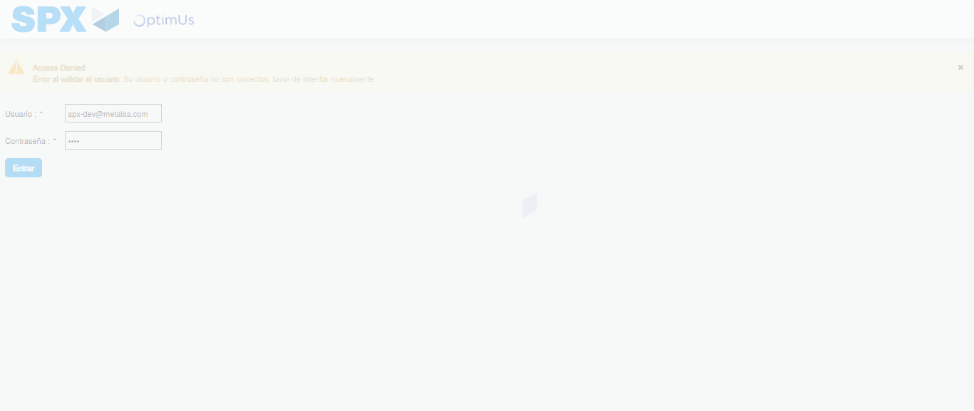Image file-name: QC_Testing-tc001_SPX_Dev5_Crear_Requisicion_Spot_Tipo_Cobro_CC-1789483062425

Step 2 - Select to UEN and Access to Spot Buy Requisitions : UEN Correctly selected and Correct access
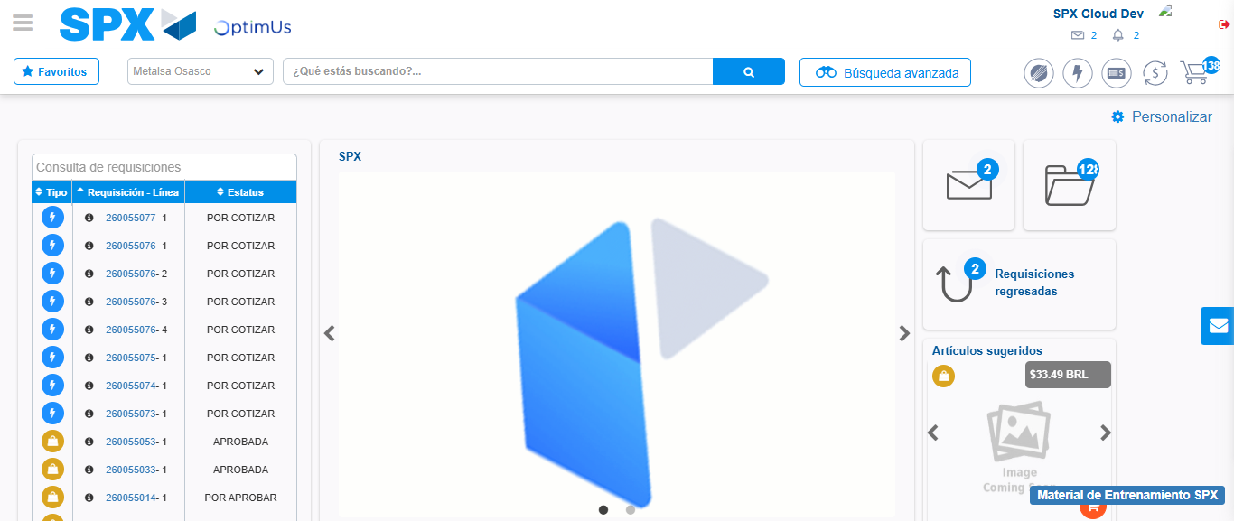Image file-name: QC_Testing-tc001_SPX_Dev5_Crear_Requisicion_Spot_Tipo_Cobro_CC-1789483085798

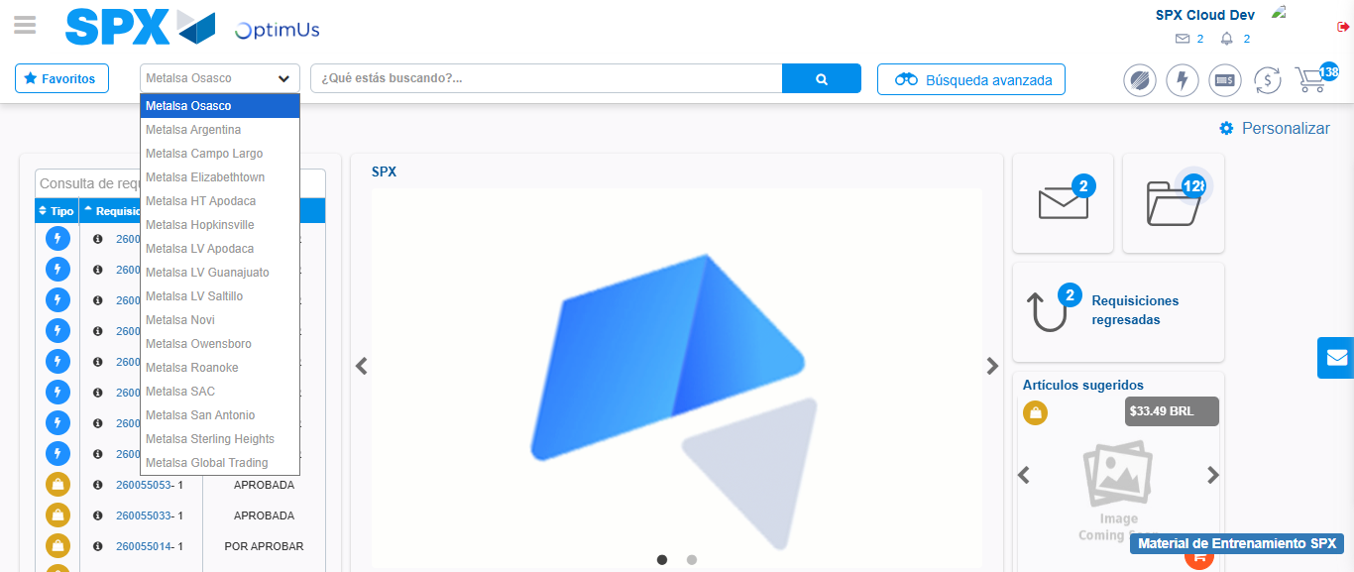Image file-name: QC_Testing-tc001_SPX_Dev5_Crear_Requisicion_Spot_Tipo_Cobro_CC-1789483086265

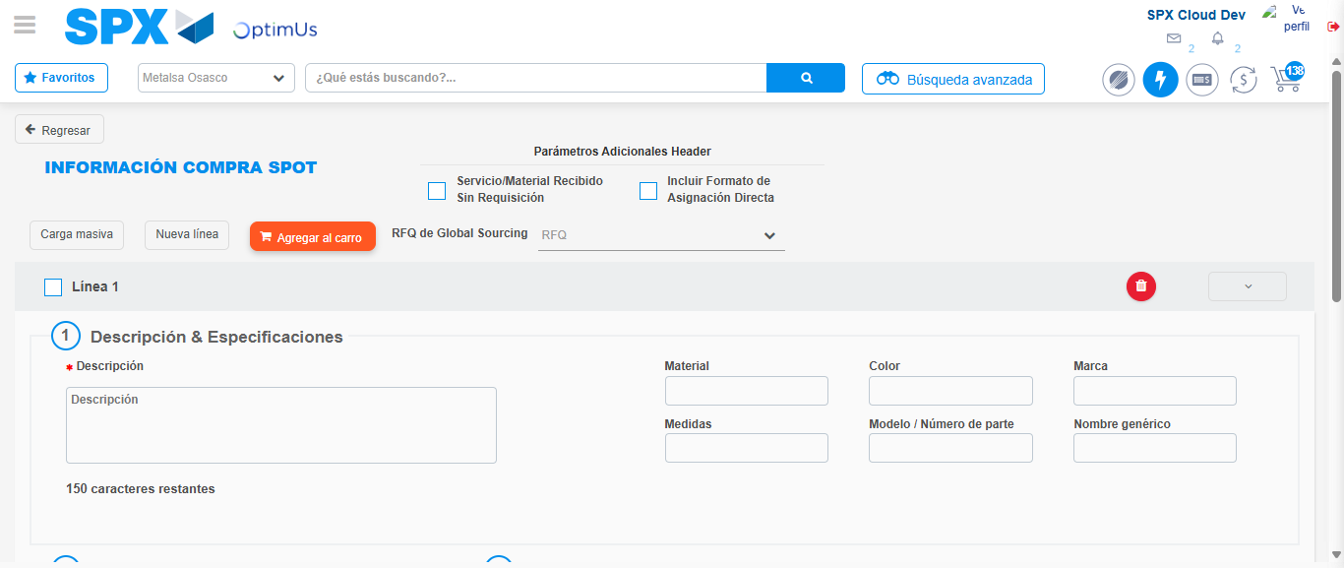Image file-name: QC_Testing-tc001_SPX_Dev5_Crear_Requisicion_Spot_Tipo_Cobro_CC-1789483090296

Step 3 - Data Capture Spot Buy Requisition : Data captured correctly
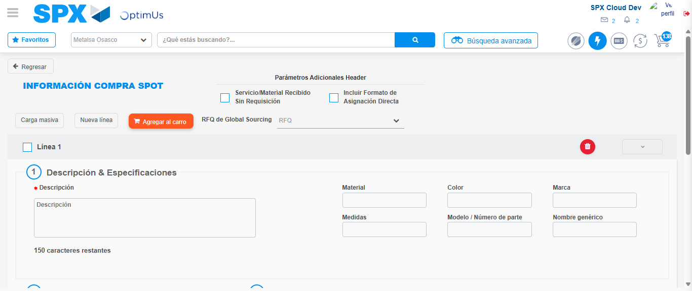Image file-name: QC_Testing-tc001_SPX_Dev5_Crear_Requisicion_Spot_Tipo_Cobro_CC-1789483090595

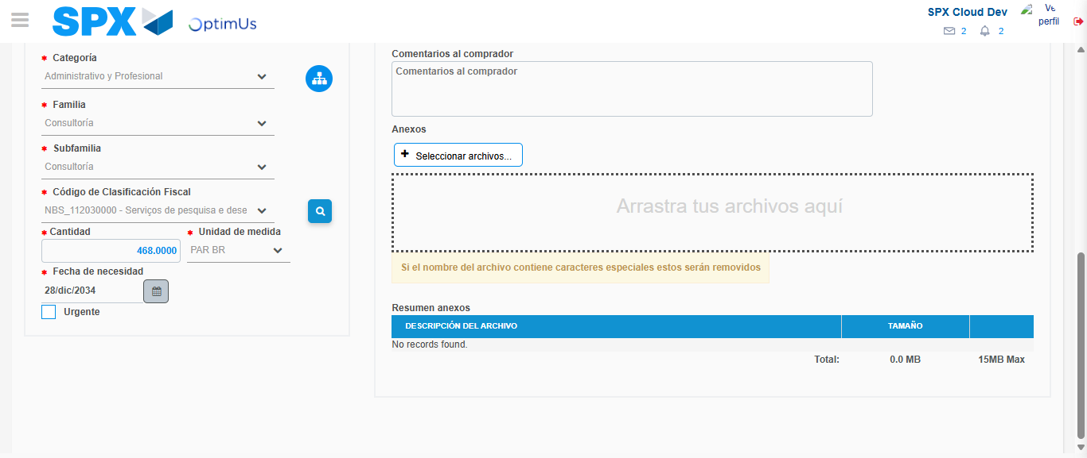Image file-name: QC_Testing-tc001_SPX_Dev5_Crear_Requisicion_Spot_Tipo_Cobro_CC-1789483104181

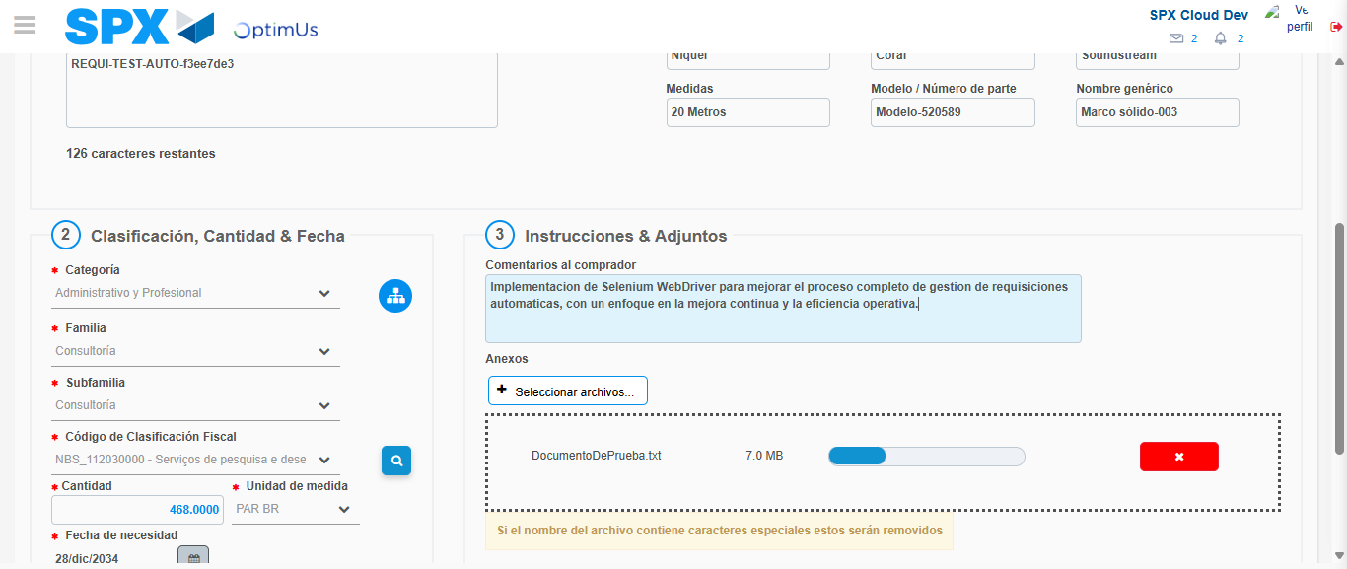Image file-name: QC_Testing-tc001_SPX_Dev5_Crear_Requisicion_Spot_Tipo_Cobro_CC-1789483104866

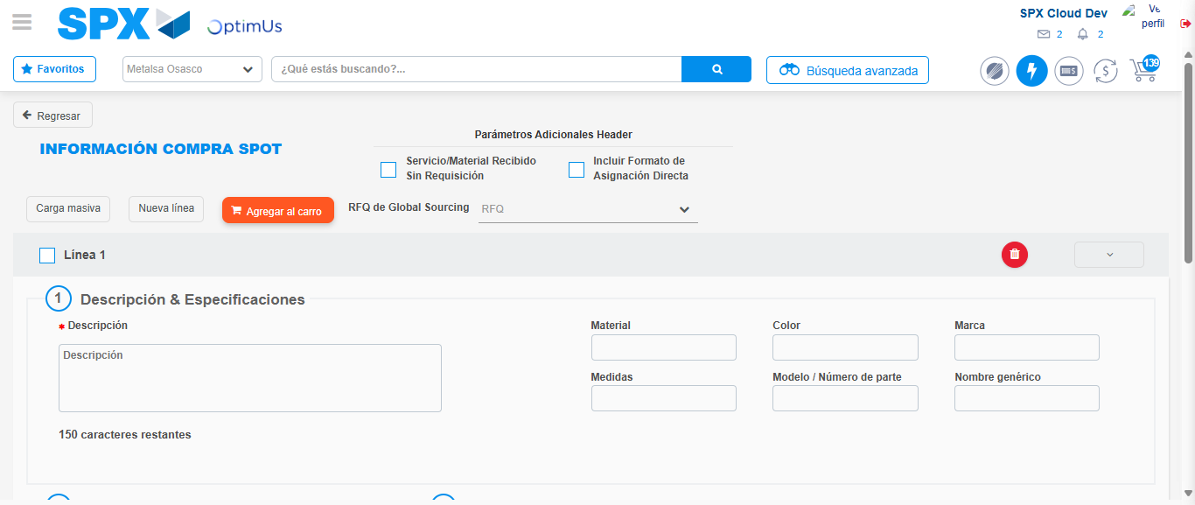Image file-name: QC_Testing-tc001_SPX_Dev5_Crear_Requisicion_Spot_Tipo_Cobro_CC-1789483106231

Step 7 - Return to Main Page SPX : Return to Main Page SPX
Image file-name: QC_Testing-tc001_SPX_Dev5_Crear_Requisicion_Spot_Tipo_Cobro_CC-1789483085798

Image file-name: QC_Testing-tc001_SPX_Dev5_Crear_Requisicion_Spot_Tipo_Cobro_CC-1789483086265

Image file-name: QC_Testing-tc001_SPX_Dev5_Crear_Requisicion_Spot_Tipo_Cobro_CC-1789483090296

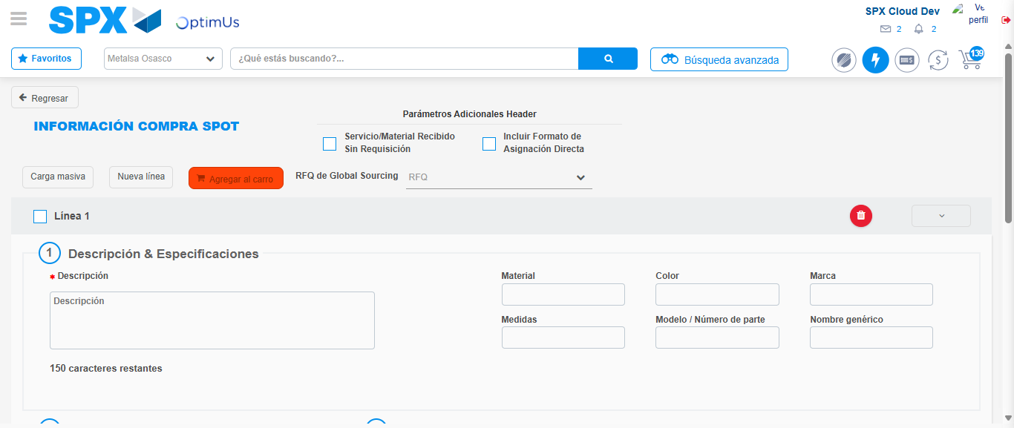Image file-name: QC_Testing-tc001_SPX_Dev5_Crear_Requisicion_Spot_Tipo_Cobro_CC-1789483108438

Image file-name: QC_Testing-tc001_SPX_Dev5_Crear_Requisicion_Spot_Tipo_Cobro_CC-1789483108561

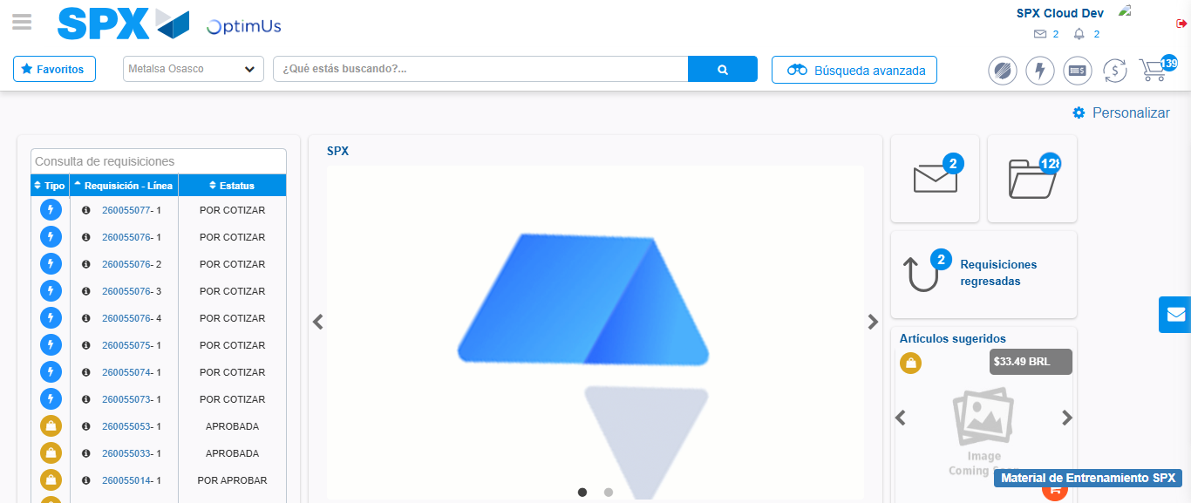Image file-name: QC_Testing-tc001_SPX_Dev5_Crear_Requisicion_Spot_Tipo_Cobro_CC-1789483129739

Step 8 - Log Out : Log Out SPX
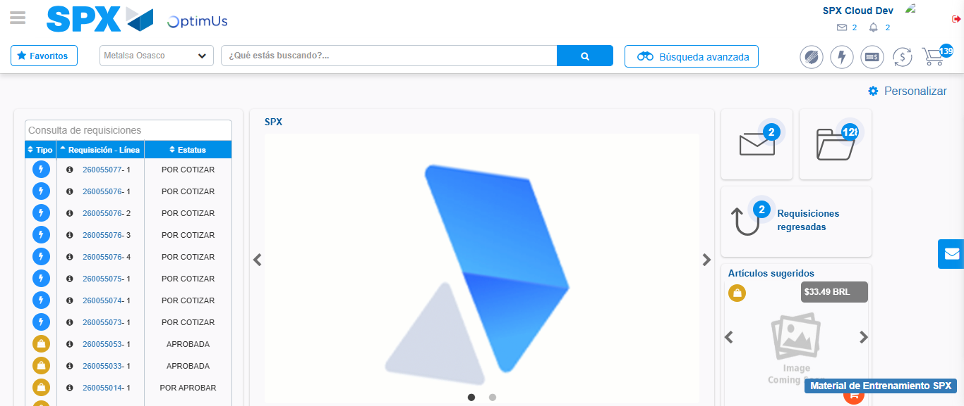Image file-name: QC_Testing-tc001_SPX_Dev5_Crear_Requisicion_Spot_Tipo_Cobro_CC-1789483130023

